|  |  |
| --- | --- |
| name | عامر عبداللة عامر سيف |
| B/N | 436 |
| Topic | Artificial intelligence |
| Git hup |  |

Artificial intelligence

**What Is Artificial Intelligence (AI)?**

\ (AI) refers to the simulation of human intelligence in machines that are programmed to think like humans and mimic their actions. The term may also be applied to any machine that exhibits traits associated with a human mind such as learning and problem-solving.The ideal characteristic of artificial intelligence is its ability to rationalize and take actions that have the best chance of achieving a specific goal.

# Understanding Artificial Intelligence When most people hear the term

artificial intelligence, the first thing they usually think of is robots. That's because big-budget films and novels weave stories about human-like machines that wreak havoc on Earth. But nothing could be further from the truth. Artificial intelligence is based on the principle that human intelligence can be defined in a way that a machine can easily mimic it and execute tasks, from the most simple to those that are even more complex. The goals of artificial intelligence include learning, reasoning, and perception.As technology advances, previous benchmarks that defined artificial intelligence become outdated. For example, machines that calculate basic functions or recognize text through optimal character recognition are no longer considered to embody artificial intelligence, since this function is now taken for granted as an inherent computer function.

AI is continuously evolving to benefit many different industries. Machines are wired using a cross-disciplinary approach based in mathematics, computer science, linguistics, psychology, and more

# Applications of Artificial Intelligence

The applications for artificial intelligence are endless. The technology can be applied to many different sectors and industries. AI is being tested and used in the healthcare industry for dosing drugs and different treatment in patients, and for surgical procedures in the operating room.

Other examples of machines with artificial intelligence include computers that play chess and sel Each of these machines must weigh the consequences of any action they take, as each action will impact the end result. In chess, the end result is winning the game. For self-driving cars, the computer system must account for all external data and compute it to act in a way that prevents a collision.

Artificial intelligence also has applications in the financial industry, where it is used to detect and flag activity in banking and finance such as unusual debit card usage and large account deposits—all of which help a bank's fraud department. Applications for AI are also being used to help streamline and make trading easier. This is done by making supply, demand, and pricing of securities easier to estimate.

Screenshots .

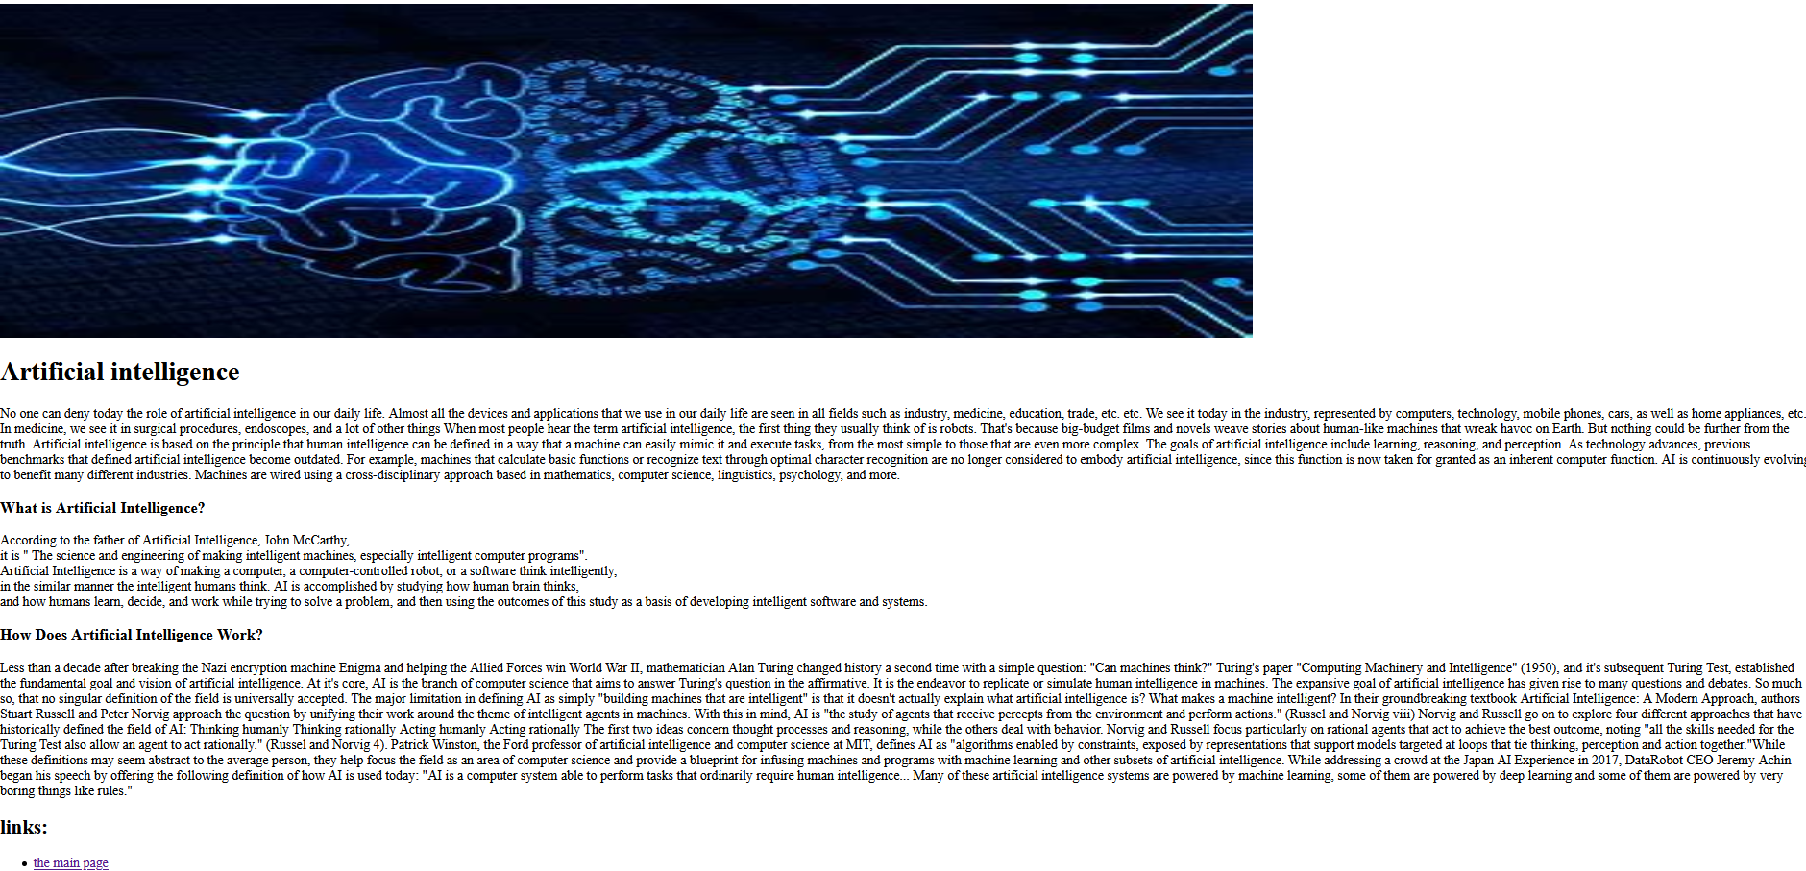

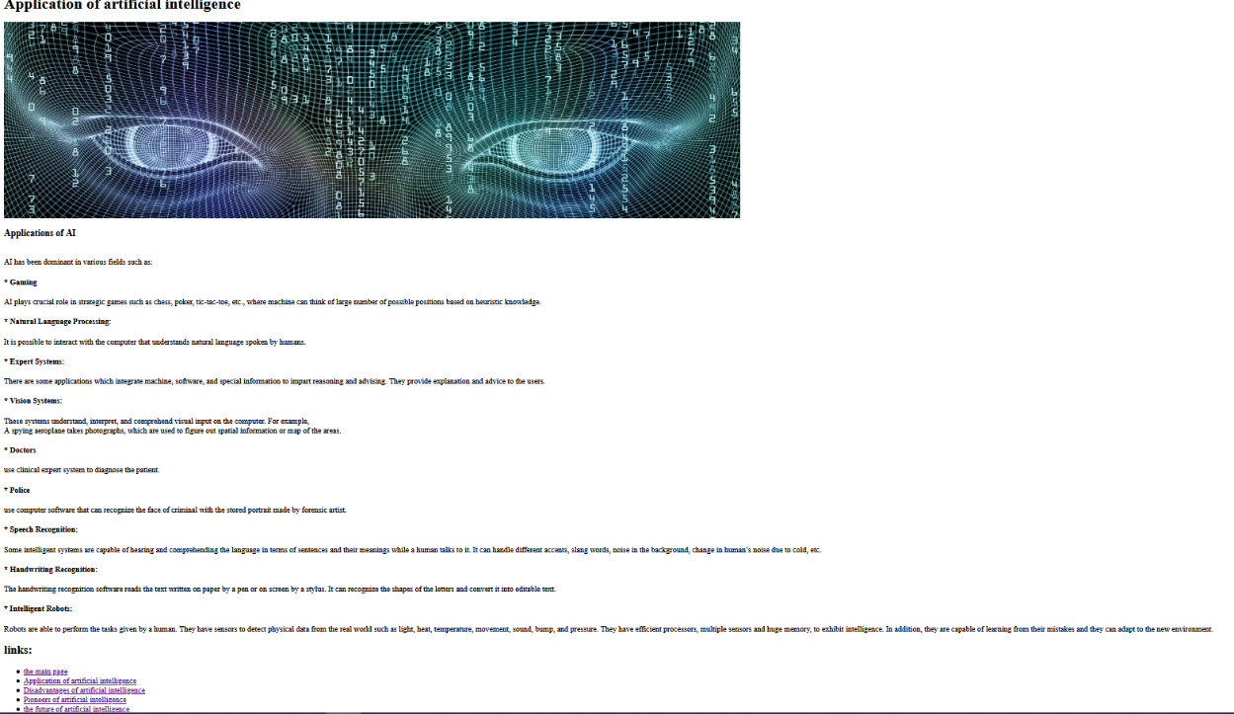

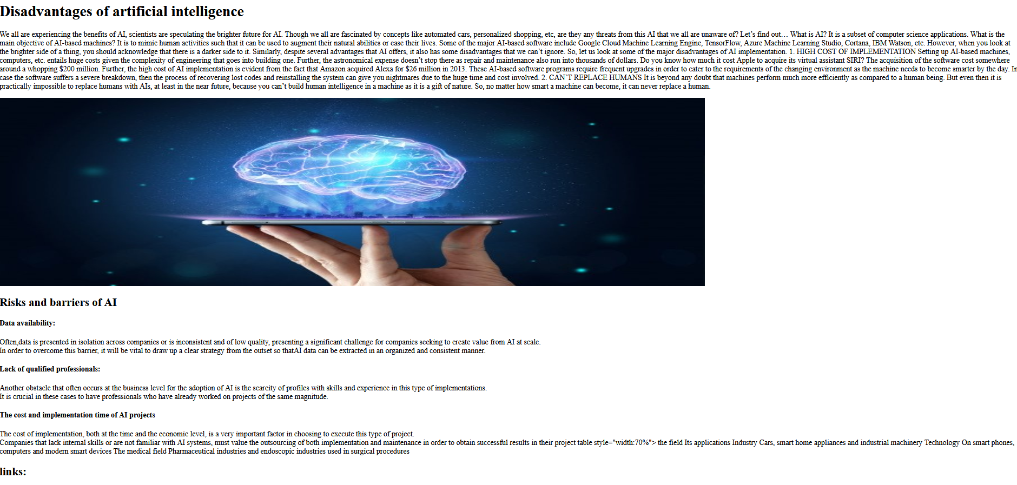

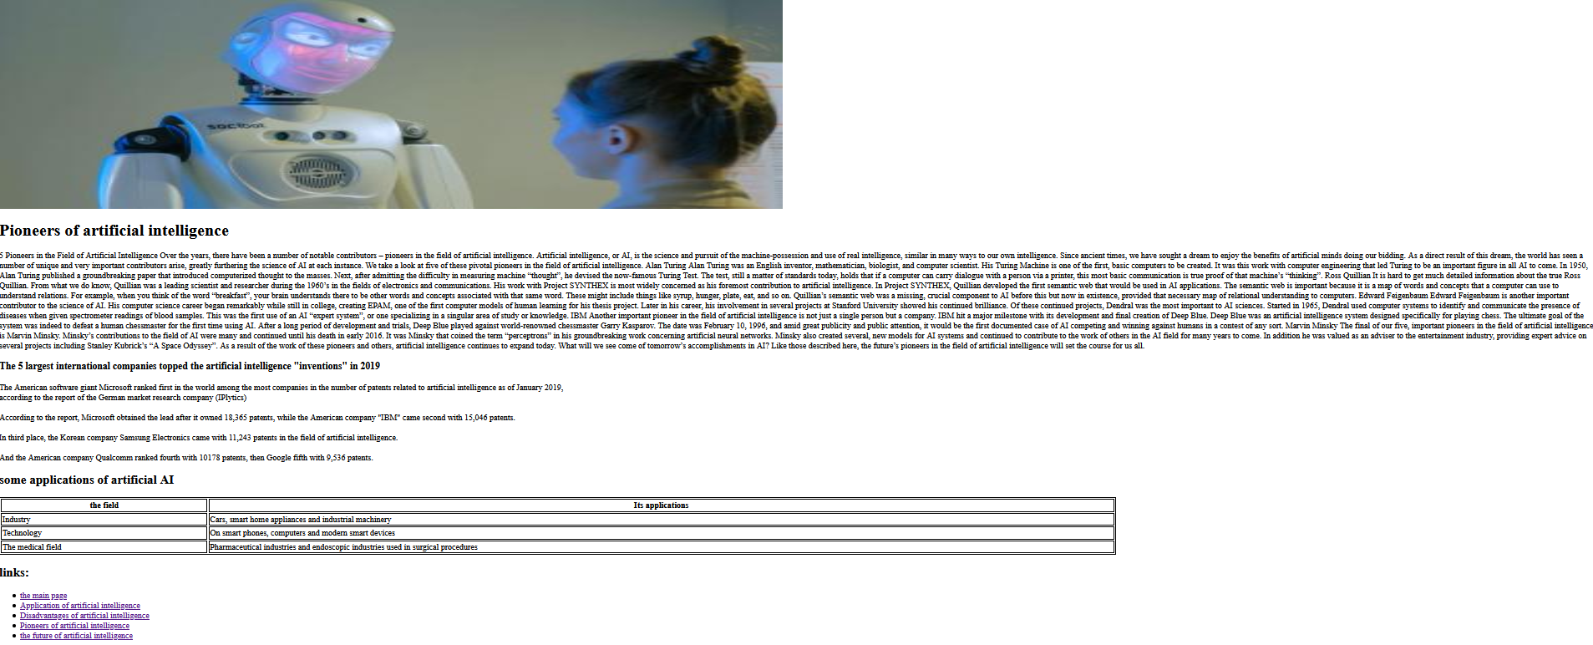

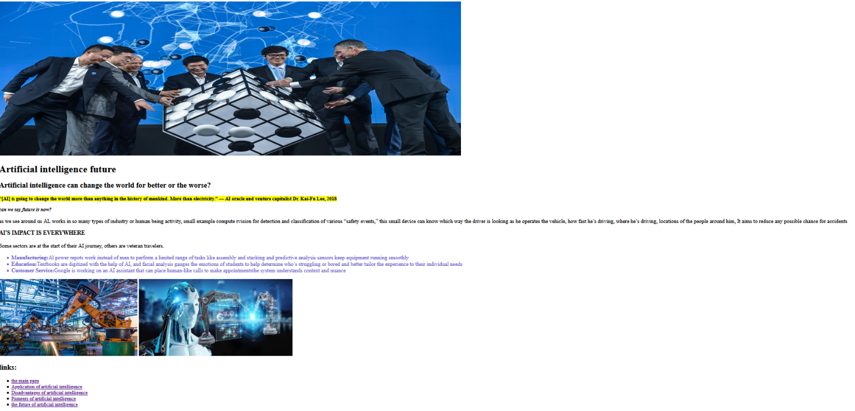

Source code

